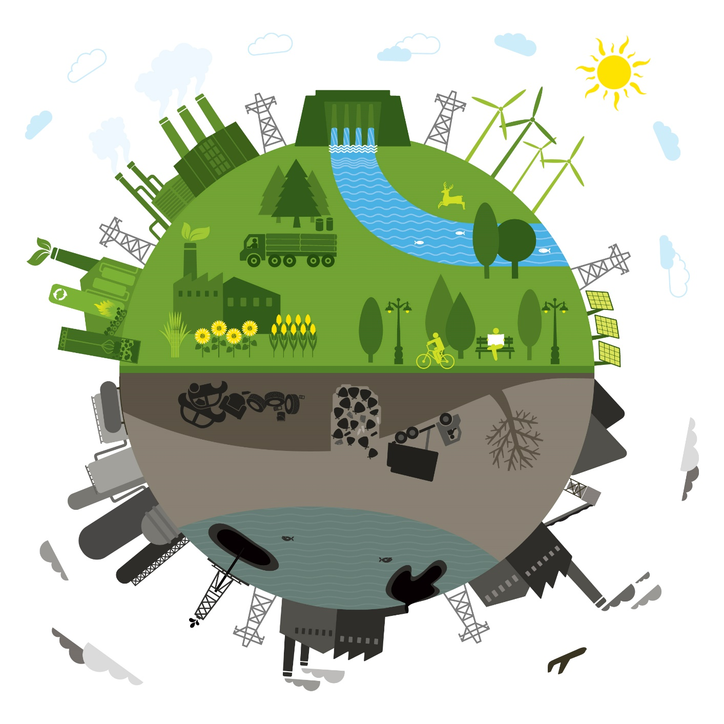

Learn what citizens and energy experts think New Brunswick’s electricity grid could and should look like in the future
Seize the opportunity to learn about the current electrical energy system and help create a future vision! (Drop in or spend the day)
When: Saturday, Oct. 3rd, 9am-4pm
Where: Wu Centre, 6 Duffie Dr. UNB Fredericton campus
Contact Prof. Tom Beckley for details: Faculty of Forestry & Environmental Mgmt, Beckley@unb.ca

